Qualtrics tips & tricks
Tip 1. Anonymous survey but separately capture contact information for incentives
Here is how to seamlessly capture identifying information for an incentive lottery drawing (e.g., win 1 of 10 gift cards from random drawing) while still maintaining anonymous survey responses. Idea:
Create 2 surveys: (1) the survey you intended to field and (2) an entirely separate 2nd survey project that only asks for lottery drawing contact information (e.g., email, name, etc.). Go to the 2nd survey, Distributions, Anonymous Link and Copy survey link:
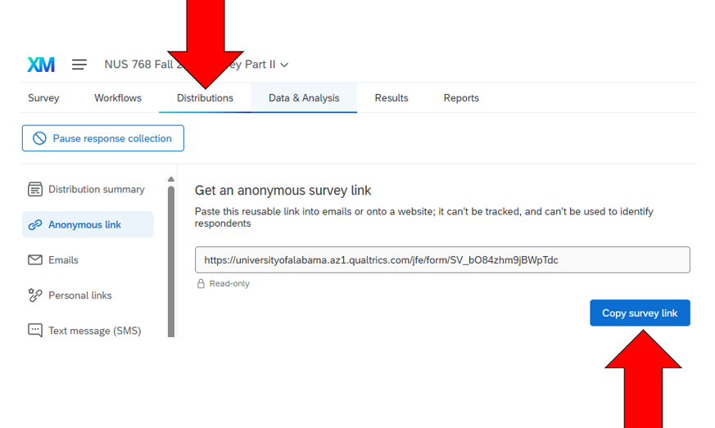

Then, go to the first survey and you can "Customize End of Survey" through Survey Flow to Redirect to a URL: https://www.qualtrics.com/support/survey-platform/survey-module/survey-flow/standard-elements/end-of-survey-element/#CustomizationOptions:
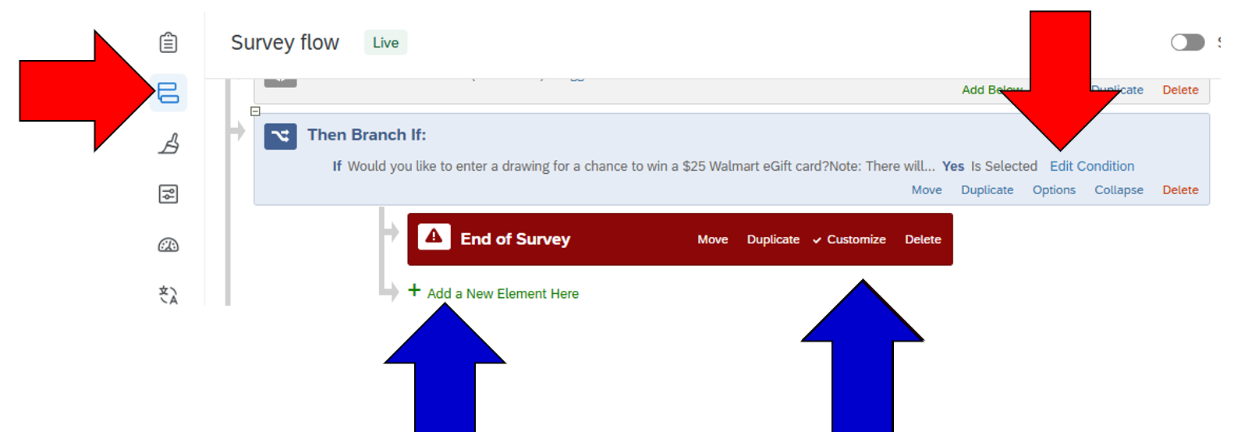
There, paste the URL for the separate 2nd survey for lottery drawing contact information into the URL box:
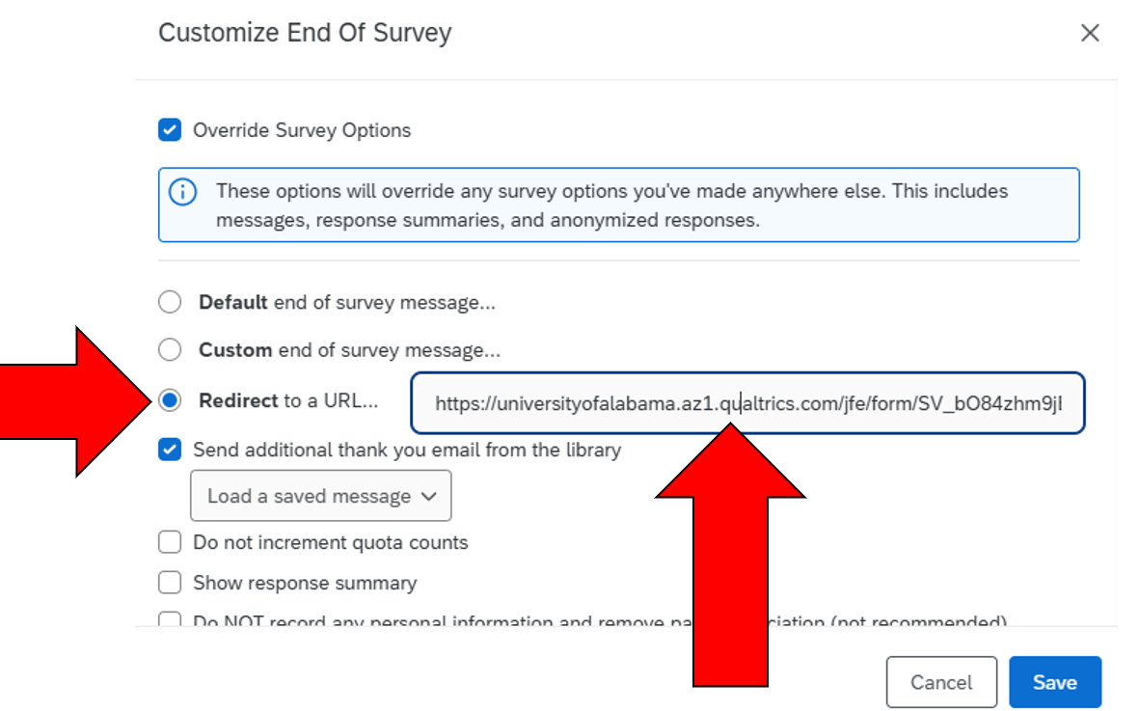

Then, when a respondent takes your survey, their data will be recorded in the first survey project completely separated from the 2nd survey project with identifiable contact information. To the respondent it will seem like one continuous overall survey.
Be sure to turn on appropriate anonymizing settings for the 1st survey as appropriate / IRB submission review. E.g., https://www.qualtrics.com/support/survey-platform/distributions-module/web-distribution/anonymous-link/Links to an external site. and
https://www.qualtrics.com/support/survey-platform/survey-module/survey-options/survey-protection/#AnonymizingResponsesLinks to an external site.
You can also add a yes/no question for respondents to opt out of providing contact information before the 2nd survey is reached at which point if they click no the survey ends. Example:
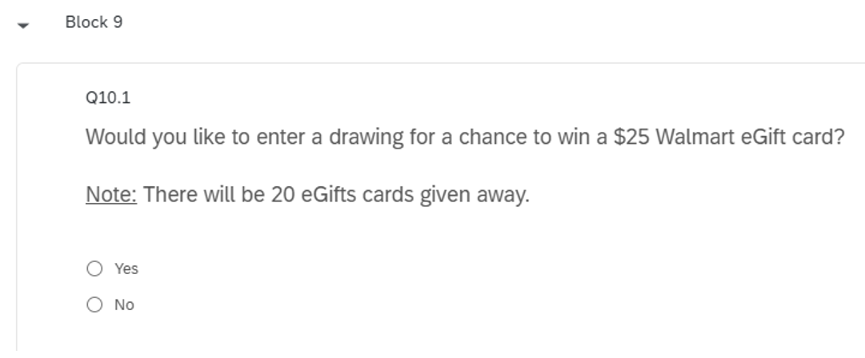
Then if they click Yes, behind the scenes the respondent will be sent to the 2nd survey and see its question(s). Example:
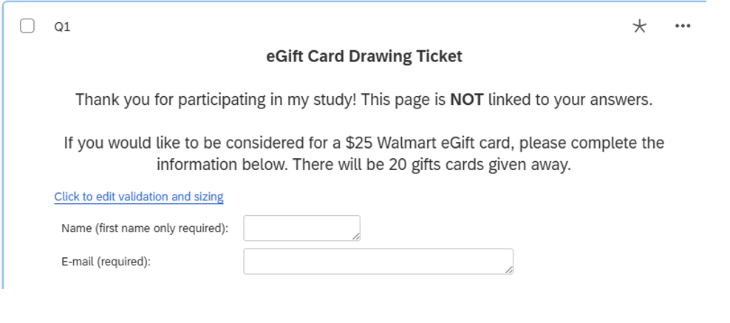

Tip 2. Exporting Data to SPSS
Were data already populated by an online web survey collection platform like Qualtrics? You can export from Qualtrics directly to SPSS. with data having these good properties, including with labeled questions and variable values. You can also save a copy of the labels in SPSS syntax language separately.

Tip 3. Qualtrics Settings to Fight Fake Submissions (e.g., by bots)
First, see this website by Qualtrics: https://www.qualtrics.com/support/survey-platform/survey-module/survey-checker/fraud-detection/
Second, some of these strategies might be useful (don't forget to include details of using in your IRB submission!)

1. Prevent Ballot Box Stuffing
Setting location: Survey Options → Security
Feature: “Prevent Ballot Box Stuffing”
Effect: Limits multiple submissions by preventing the same browser (via cookies) from submitting more than once.
✓ Best for: Basic prevention of repeat responses.

2. Use reCAPTCHA
Setting location: Survey Flow → Add a New Element → Authenticator → Choose reCAPTCHA
Feature: Adds a Google reCAPTCHA (v2 or v3) challenge to the survey.
Effect: Detects and blocks non-human behavior (bots).
✓ Best for: Stopping scripted and automated bot entries.

3. Use Bot Detection Metadata
Setting location: Survey Flow → Add a New Element → Embedded Data → Add Field: Q_BotDetectorResult
Feature: Records if Qualtrics suspects a bot (value = "Bot" or "Human")
Effect: Lets you filter out or terminate suspected bots mid-survey.
✓ Best for: Post-hoc filtering or real-time disqualification.

4. GeoIP Location Filtering
Setting location: Survey Flow → Add Embedded Data (e.g., GeoIPCountry, GeoIPRegion)
Feature: Blocks or flags responses from unexpected countries or regions.
Effect: Allows restriction to certain locations or regions, reducing risk of overseas bot farms.
✓ Best for: Targeting a known geographic sample.

5. Use an Authenticator (e.g., Email, SSO)
Setting location: Survey Flow → Add Authenticator
Feature: Requires participants to log in with a known identifier (e.g., SSO, email list).
Effect: Ensures only verified individuals access the survey.
✓ Best for: Closed or invite-only surveys.

6. Add Attention Checks / CAPTCHA-style Questions
Setting location: Within survey questions (manually added)
Feature: Human verification items like “Select ‘Strongly Agree’ for this question.”
Effect: Helps weed out automated or inattentive responses.
✓ Best for: Catching low-effort bots or fake respondents.

7. Use Timing Metrics
Tool: Add Timing questions or Response Duration as metadata
Effect: Flag extremely short or fast completions typical of bots.

8. Review Anonymous Link Settings
Avoid posting open anonymous links widely unless you add the above safeguards.
• If feasible, use personal links (email distribution via Qualtrics).

9. Block Suspicious User Agents or IPs (Advanced)
Requires: Custom code or pre-processing after export
• Example: Use Q_UserAgent and Q_IPAddress for analysis/filtering

If bot submissions are already occurring, you can also apply filters using:
- Q_BotDetectorResult
- Very short Duration (in seconds)
- Q_GeoIPCountry mismatch
- Q_UserAgent anomalies

Tip 4. Embed questions to catch fake respondents / fraud detection

1. Instructional Manipulation Checks (IMCs)
How it works: Embed a question that looks like a normal one but instructs the respondent to select a specific answer.
Example: “To show that you are paying attention, please select ‘Strongly Disagree’ for this item.”
Why it's effective: Bots and inattentive respondents tend to miss embedded instructions.
✓ Modern Tip: Rotate position in the survey and vary language to reduce memorization.

2. Semantic or Logical Inconsistency Checks
How it works: Ask pairs of questions that should yield logically consistent answers.
Example:
- Q1: “I have never used social media.”
- Q2: “How often do you post on Instagram?”
Flag if: Respondent claims never to use social media but answers Instagram usage.

3. Speed-Bump Questions
How it works: Use simple cognitive tasks or logic-based questions that humans can solve easily.
Example: “If you’re reading this, choose option C below.” Or: “Which of the following is the largest: 8, 3, 10, or 6?”
✓ Good for: Bots that skim or select randomly.

4. IP/Geo-Mismatch and Language-Trap Questions
How it works: Compare reported geographic or language info to embedded responses.
Example: Ask “Which U.S. state are you currently in?” but also check IP-derived location using Qualtrics metadata.
Flag if: IP address is in Nigeria but response says “California.”
✓ Modern addition: Combine with metadata fields like GeoIPCountry, UserAgent, Accept-Language.

5. Impossible Behavior or Demographic Combinations
How it works: Ask for combinations that are unlikely or impossible.
Example:
- Q1: Age = 17
- Q2: “How many years have you worked as a registered nurse?” → 15
Why it's effective: Fabricated profiles often lack internal logic.
✓ Best for: Survey panels or screening surveys.

6. Response Pattern Traps
How it works: Insert repetitive items or reverse-coded versions of the same construct.
Flag if: Respondent gives same rating (e.g., all 5s) even to contradictory items.
✓ Advanced use: Analyze response variance across matrix questions.

7. Qualtrics Bot Detection + Embedded Behavior
How it works: Use Qualtrics’ internal scoring to embed Q_BotDetectorResult, and terminate or flag if value is “Bot.”
Pair it with: Embedded questions that require reflection or open-text responses.

8. Honey-Pot Questions (Advanced)
How it works: Insert a hidden question not visible to real users but visible to bots scraping the survey.
Effect: If the hidden question is answered, it’s likely a bot.
Example:
First, go to Survey Flow and Add New Element you will move to the very top before anything else. Add Set Embedded Data with the two fields set to 0:
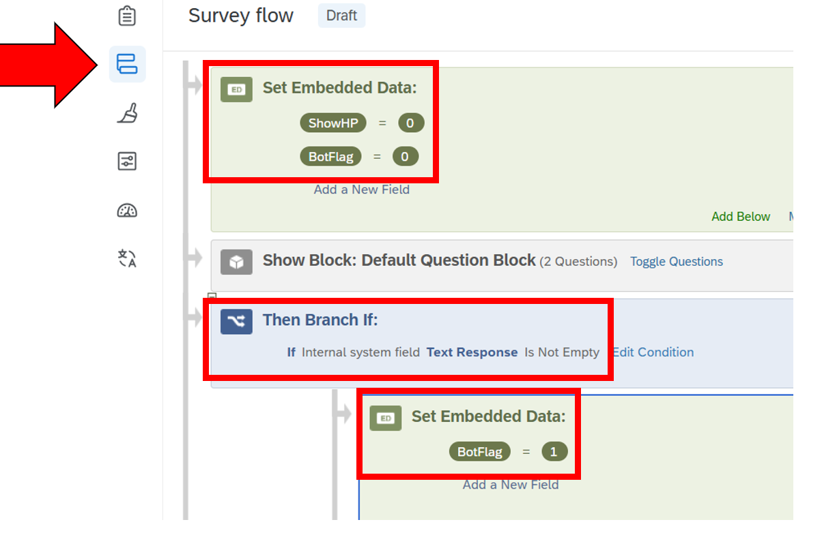
Then go back to the survey and add a text entry question and label it something like "internal system field" Now click on Display logic and add if ShowHP Is Equal to 1:
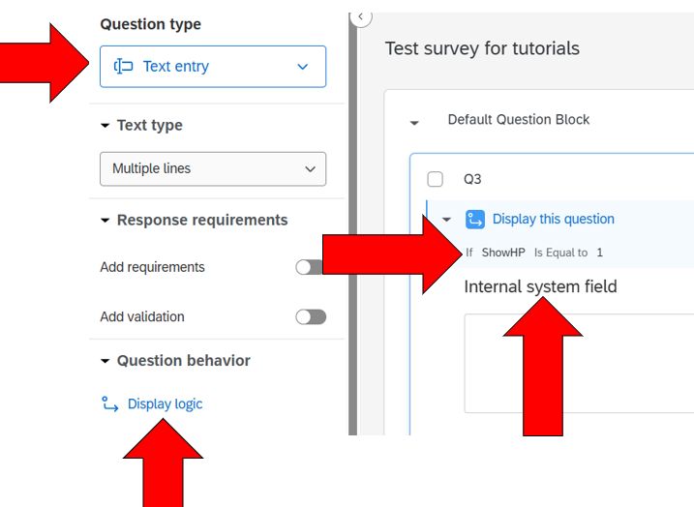
For the Display logic settings:
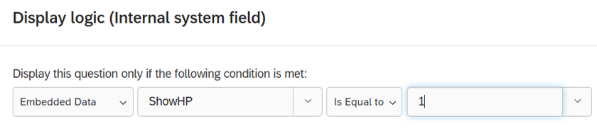
That should do it. Go to Preview to Preview the survey and the honeypot question should be hidden to actual respondents:

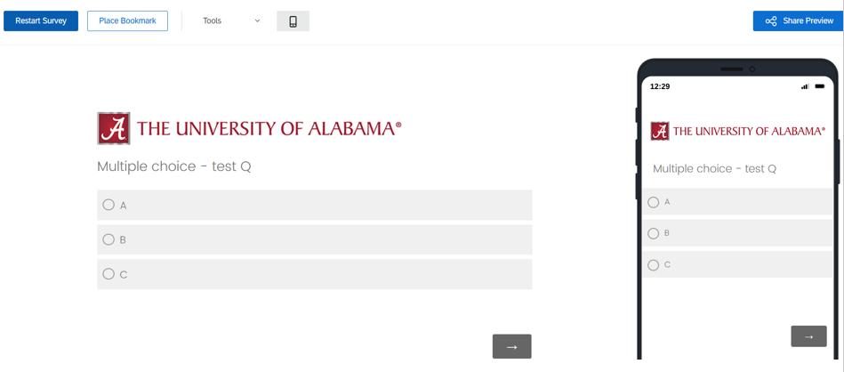
But visible to bots. Then after you download data, you can identify those who answered the honeypot question by BotFlag=1 (e.g., to delete/exclude from data analysis).

